Ellen Slocum: Geogebra Lesson- Transformations of Functions
- Transforming Functions is a way to change a function from its most basic form (the parent function).
- When it comes to functions, transformations could include translations (slides), reflections (flips), and dilations (stretches or shrinks).
- Graphs are transformed as various operations are performed including addition, subtraction, and multiplication.
- A Parent Function is the basic function of a family of functions.
Examples of Parent Functions:
Quadratic  The most basic quadratic you can have is… | Cubic  The most basic cubic function you can have is…
$$y=x^{2}$$  When graphed it looks like this…  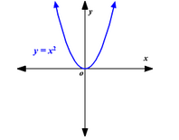 | $$y=x^{3}$$  When graphed it looks like this…  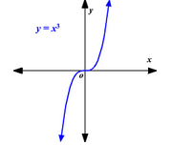

To examine some transformations of functions we are going to look at the possible effects on the $x^{3}$ graph through the use of Geogebra.
- Open Geogebra on your computers.

- Inputting the Parent Function: We will first be examining the effects of addition and subtraction on the $x^{3}$ graph (our parent function). In the input bar type the following function and press enter:
  - f(x) = $x^{3}$
*TYPE: f(x)=x^3*

Note: We are going to be inputting A LOT of functions so it may be helpful to change the color and line style of each function entered. To do use the following these steps:
- Click the 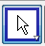 button then click on the function you have just graphed.
- Right click and select OBJECT PROPERTIES
- Use the color tab and style tab to adjust LINE COLOR and LINE THICKNESS then click the 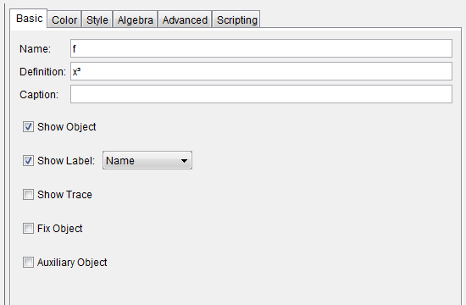

- Select 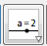 to create a slider and click the screen to arrive at the slider menu:
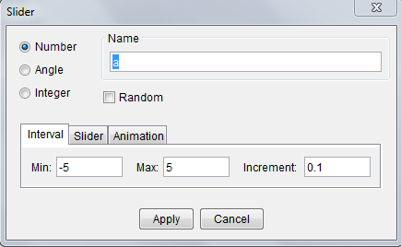
Using this menu choose “number”, change the name of your variable to “c”, and adjust the interval so it has a minimum of 0 and a maximum of 5. When this is done, press apply.
*If this slider is in the way of your graph move click and drag it to a better position, if this does not work right click and uncheck “FIX OBJECT” *

- Now that we have typed the parent function we are going to input some possible changes (transformations) we could see to the graph. In the input bar type the following functions, pressing enter after each is typed:
  - g(x) = f(x) + c
  - h(x) = f(x) – c
  - p(x) = f(x + c)
  - q(x) = f(x – c)

Change the color and line style of each of these lines so you can easily tell them apart (use the instructions above to do this)

- After inputting each transformation click the green circle next to it hide it from the graph, once this is done it will look something like this:
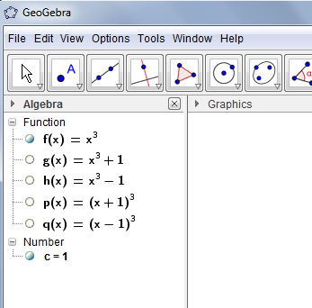
*the parent function, f(x), should be the only function with a filled in circle at this time*

- Click on the circle next to the first function g(x) so that the graph is now visible.

- Move the slider and observe the change between this graph and the parent graph.
  - What do you notice? Fill in the statement below:
When I add a number outside the parenthesis the graph slides ___________________.

- Unclick the function you were just working with g(x) and click on the circle next to the function h(x) so that the graph is visible.

- Move the slider and observe the change between this graph and the parent graph.
  - What do you notice? Fill in the statement below:
When I subtract a number outside the parenthesis the graph slides ___________________.

- Unclick the function you were just working with h(x) and click on the circle next to the function p(x) so that the graph is visible.

- Move the slider and observe the change between this graph and the parent graph.
  - What do you notice? Fill in the statement below:
When I add a number inside the parenthesis the graph slides ___________________.

- Unclick the function you were just working with p(x) and click on the circle next to the function q(x) so that the graph is visible.

- Move the slider and observe the change between this graph and the parent graph.
  - What do you notice? Fill in the statement below:
When I subtract a number inside the parenthesis the graph slides ___________________.

- Fill in this chart with your conclusions:
Translations (slides)
 | Add | Subtract
Inside Parenthesis
Outside Parenthesis

- We will now be examining the effects of multiplying by a negative on a graph. We will do this by looking at a graph that we have already used, called g(x). In the input bar type the following functions and press enter after each.
  - r(x) = -g(x)
  - s(x) = g(-x)

*again remember that it will be helpful to change the color and line style of your graph, the directions are listed above*

- After inputting each transformation click the green circle next to it hide it from the graph, once this is done it will look something like this:
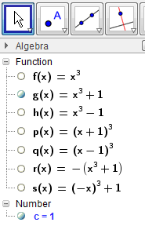
*the function g(x) should be the only function with a filled in circle at this time*

- Click on the circle next to the function r(x) so that the graph is now visible.

- Examine the relationship between g(x) and r(x).
  - What do you notice? Fill in the statement below:
When I multiply by a negative number outside the parenthesis, the graph reflects over the _______________.

- Unclick the circle next to the function r(x) and click on the circle next to the function s(x) so that the graph is now visible.

- Examine the relationship between g(x) and s(x).
  - What do you notice? Fill in the statement below:
When I multiply by a negative inside the parenthesis, the graph reflects over the __________________.

- Fill in this chart with your conclusions:
Reflections (flips)
Multiply
Inside Parenthesis
Outside Parenthesis

Extra Problems:

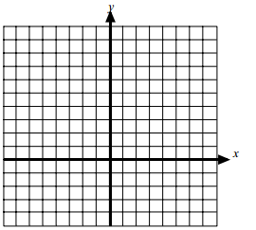
- On the blank grid, sketch the graph of $y=x^{2}$, on the same grid (and without a graphing calculator) sketch the function $y=x^{2}+2$ and $y=x^{2}-3$.
- On the blank grid, sketch the graph of $y=x^{2}$, on the same grid (and without a graphing calculator) sketch the function $y={-(x-1)}^{2}$ and $y={(-x+3)}^{2}$.

- Write an equation that will move the function $y=x^{2}$ right 3 units and up 2.

- Write an equation that will move the function $y=x^{2}$ left 5 units and up 6 units.

Sources:
http://lyt.weebly.com/uploads/2/0/9/5/2095912/function_translations_review.pdf http://education.ti.com/sites/UK/downloads/pdf/scotland/fnctrans.pdf

